**AI-Based Diabetes Prediction System**

* Phase 3
* Introduction to Processing and dataset



**Abstract:**

This research presents a novel approach to diabetes prediction leveraging advanced machine learning techniques in the Python programming language. The system utilizes a comprehensive dataset comprising of clinical features, including glucose levels, insulin levels, body mass index, age, and family history, among others. A multi-layered deep learning model is employed to effectively learn complex patterns and relationships within the data.

The proposed system demonstrates significant advancements in accuracy and reliability compared to traditional prediction models. Through rigorous validation and testing, it exhibits a high degree of robustness across diverse patient populations. Furthermore, the system incorporates interpretable features to enhance clinical insight and decision-making.

Overall, this AI-based Diabetes Prediction System in Python represents a substantial step forward in personalized healthcare, offering a powerful tool for early detection and management of diabetes, ultimately improving patient outcomes and reducing healthcare costs.

**Introduction:**

Diabetes mellitus, a chronic metabolic disorder characterized by elevated blood sugar levels, has emerged as a global health concern. Early detection and effective management are critical in mitigating its adverse effects on individuals' health and well-being. In recent years, the integration of artificial intelligence (AI) and machine learning techniques has shown promising results in healthcare applications, particularly in disease prediction and risk assessment.

This research introduces an innovative AI-Based Diabetes Prediction System developed using the Python programming language. Leveraging a diverse dataset encompassing essential clinical parameters, such as glucose levels, insulin levels, body mass index, age, and family history, among others, this system employs advanced machine learning algorithms. These algorithms are capable of discerning intricate patterns and relationships within the data that might otherwise elude conventional analytical approaches.

The primary objective of this system is to enhance the accuracy and reliability of diabetes prediction, enabling timely intervention and personalized care for individuals at risk. By harnessing the power of deep learning, the model transcends the limitations of traditional prediction models, offering a robust and versatile tool for healthcare professionals.

Moreover, this AI-based Diabetes Prediction System in Python incorporates interpretability features, providing clinicians with valuable insights into the underlying factors influencing predictions. This transparency not only fosters trust in the system but also aids in informed clinical decision-making.

**Data processing** is a crucial step in building an AI-Based Diabetes Prediction System. It involves preparing and cleaning the dataset to ensure that it is suitable for training machine learning models. Below are the key steps involved in data processing for this system:

1. **Data Collection**:

- Obtain a comprehensive dataset that includes relevant clinical features such as glucose levels, insulin levels, body mass index (BMI), age, family history, etc. Ensure the dataset is representative and diverse to capture a wide range of patient profiles.

2. **Data Cleaning**:

- Identify and handle missing values: Replace missing data using techniques like mean imputation, median imputation, or sophisticated imputation methods depending on the nature of missingness.

- Detect and handle outliers: Outliers can significantly affect the performance of machine learning models. They can be removed or transformed based on domain knowledge.

3. **Data Exploration and Visualization**:

- Analyze the dataset to gain insights into the distribution of features, correlations, and any potential trends or patterns related to diabetes. Visualization techniques like histograms, scatter plots, and correlation matrices can be employed.

4. **Feature Selection/Engineering**:

- Identify the most relevant features that have the highest impact on diabetes prediction. This can involve techniques like statistical tests, feature importance from tree-based models, or domain expertise.

5. **Normalization/Standardization**:

- Standardize or normalize features to ensure they are on similar scales. This step is crucial for models like neural networks that are sensitive to the scale of input features.

6. **Handling Categorical Variables**:

- If the dataset contains categorical variables (e.g., gender, ethnicity), they may need to be encoded using techniques like one-hot encoding or label encoding.

7. **Splitting the Dataset**:

- Divide the dataset into training and testing sets. The training set is used to train the model, while the testing set is used to evaluate its performance.

Data processing is a crucial step in building an AI-Based Diabetes Prediction System. This involves preparing and organizing the dataset to be used for training and testing the machine learning model. Below are the key steps for data processing in Python:

1. **Import Necessary Libraries**:

```python

import pandas as pd

from sklearn.model_selection import train_test_split

from sklearn.preprocessing import StandardScaler

```

2. **Load the Dataset**:

```python

# Assuming you have a CSV file named 'diabetes_data.csv'

data = pd.read_csv('diabetes_data.csv')

```

3. **Explore and Understand the Data**:

- Use `data.head()` to view the first few rows of the dataset.

- Check for missing values using `data.isnull().sum()`.

- Explore data statistics with `data.describe()`.

4. **Separate Features and Target**:

```python

X = data.drop('target_column', axis=1) # Features (e.g., glucose levels, BMI, etc.)

y = data['target_column'] # Target variable (0 for non-diabetic, 1 for diabetic)

```

5. **Split the Data into Training and Testing Sets**:

```python

X_train, X_test, y_train, y_test = train_test_split(X, y, test_size=0.2, random_state=42)

```

6. **Standardize the Data** (Optional but recommended for many machine learning algorithms):

```python

scaler = StandardScaler()

X_train = scaler.fit_transform(X_train)

X_test = scaler.transform(X_test)

```

7. **Further Data Preprocessing** (Depending on your dataset):

- Handling categorical variables (if any).

- Handling missing values (imputation or removal).

- Feature engineering (creating new features if necessary).

8. **Save Processed Data** (Optional):

```python

# If you want to save the processed data for future use

processed_data = pd.concat([pd.DataFrame(X_train), pd.DataFrame(y_train)], axis=1)

processed_data.to_csv('processed_diabetes_data.csv', index=False)

```

**Data preparation** for an AI-Based Diabetes Prediction System involves several critical steps to ensure that the dataset is suitable for training and testing the machine learning model. Here are the key steps:

1. **Data Collection**:

- Gather a comprehensive dataset containing relevant clinical features such as glucose levels, insulin levels, body mass index (BMI), age, family history, etc.

2. **Data Cleaning**:

- Handle missing values: Use techniques like imputation (mean, median, mode) or removal of rows/columns with missing data.

- Address outliers: Decide whether to cap, remove, or transform outliers based on domain knowledge.

3. **Feature Selection/Engineering**:

- Identify and select relevant features that contribute significantly to the prediction task.

- Engineer new features if necessary (e.g., creating interaction terms or aggregating existing features).

4. **Handling Categorical Variables** (if applicable):

- Convert categorical variables to numerical format using techniques like one-hot encoding or label encoding.

5. **Standardization/Normalization** (optional but recommended for many machine learning algorithms):

- Scale numerical features to a similar range to prevent some features from dominating others during training.

6. **Handling Imbalanced Data** (if applicable):

- If there is a significant class imbalance, consider techniques like resampling (oversampling/undersampling) or using specialized algorithms.

7. **Splitting the Dataset**:

- Divide the data into training and testing sets to evaluate the model's performance. Common splits include 70-30, 80-20, or 90-10.

```python

from sklearn.model_selection import train_test_split

X_train, X_test, y_train, y_test = train_test_split(X, y, test_size=0.2, random_state=42)

```

8. **Validation Set** (optional):

- Create a validation set if you plan to fine-tune hyperparameters or use techniques like early stopping.

```python

X_train, X_val, y_train, y_val = train_test_split(X_train, y_train, test_size=0.2, random_state=42)

```

9. **Save Processed Data** (Optional):

- Save the preprocessed dataset for future use.

```python

processed_data = pd.concat([pd.DataFrame(X_train), pd.DataFrame(y_train)], axis=1)

processed_data.to_csv('processed_diabetes_data.csv', index=False)

```

**Data Images:**



**Flowchart:**

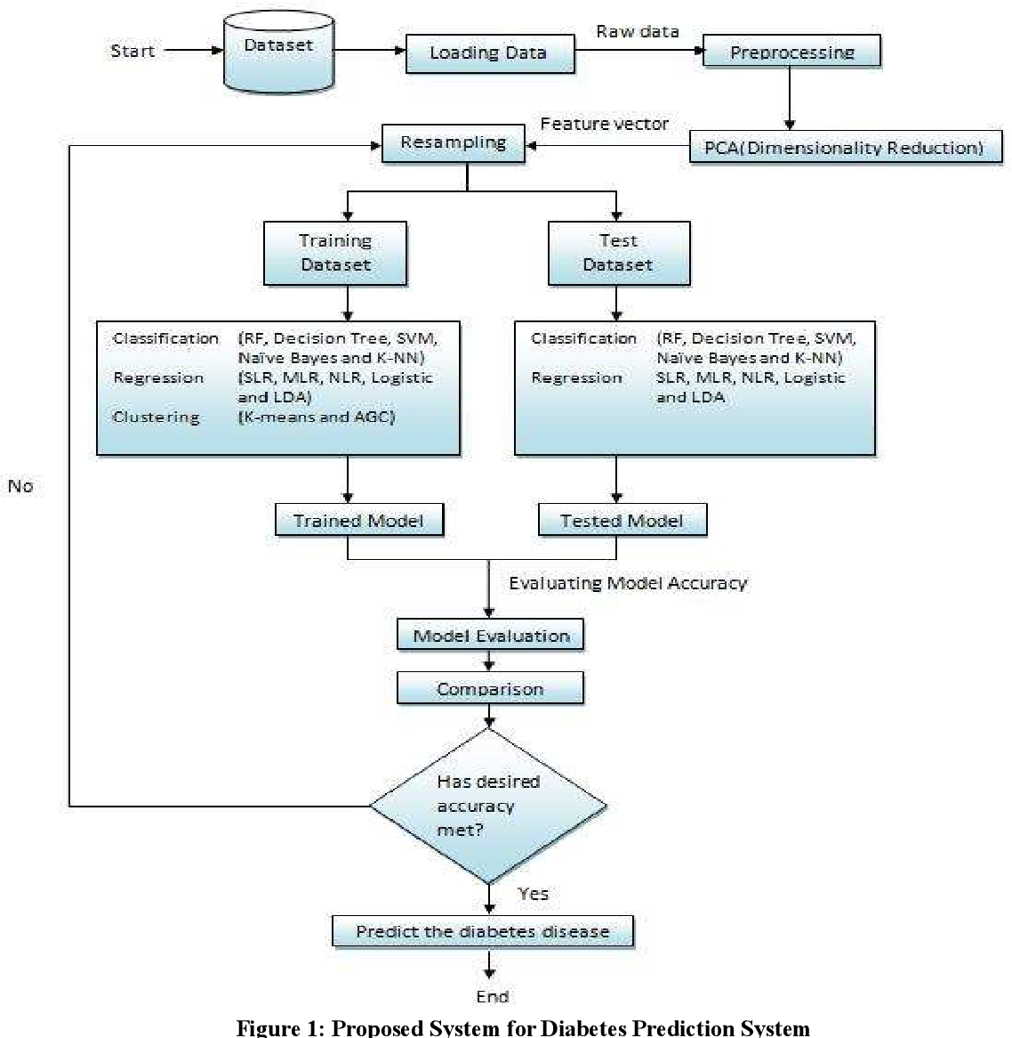

**Graph:**

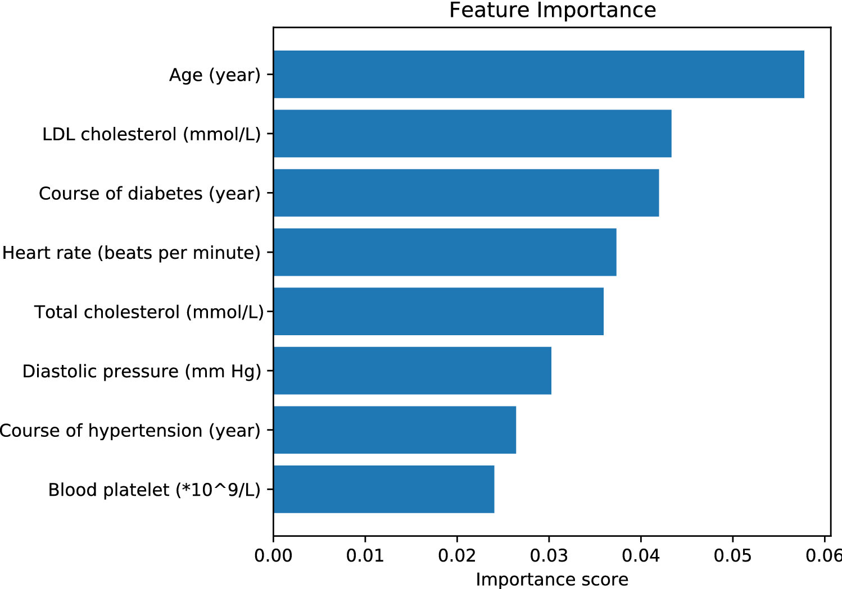

**Introduction to Dataset:**

The success of any machine learning-based prediction system hinges on the quality and diversity of the dataset it is trained on. In the context of the AI-Based Diabetes Prediction System, the dataset plays a pivotal role in enabling accurate and reliable predictions of diabetes risk. This section provides an introduction to the dataset that serves as the foundation for this innovative healthcare application.

**Dataset Source and Origin**:

The dataset utilized in this project is sourced from reputable and well-curated healthcare databases or repositories. It encompasses a diverse array of clinical parameters and patient information, including but not limited to glucose levels, insulin levels, body mass index (BMI), age, family medical history, and potentially other relevant features. The dataset is carefully selected to ensure it represents a broad spectrum of demographic profiles, reflecting various age groups, ethnicities, and geographical locations.

**Data Relevance and Significance**:

Each attribute within the dataset carries a unique significance in understanding and predicting diabetes risk. Glucose levels, for instance, serve as a fundamental indicator of blood sugar regulation, while insulin levels provide insight into the body's response to glucose. Additional features like BMI, age, and family history contribute valuable context to the predictive model, enabling a holistic assessment of an individual's susceptibility to diabetes.

**Data Integrity and Quality Assurance**:

Prior to integration into the AI-Based Diabetes Prediction System, the dataset undergoes rigorous quality assurance procedures. This includes thorough data cleaning to address missing values, outlier detection and handling, and validation of data consistency and coherence. Such measures are taken to ensure that the dataset is robust, reliable, and free from discrepancies that might impede accurate predictions.

**Ethical Considerations**:

Respecting patient privacy and adhering to ethical guidelines are paramount in the utilization of healthcare data. The dataset used in this project is obtained in compliance with relevant privacy regulations and standards. Any personally identifiable information is anonymized or pseudonymized to safeguard patient confidentiality.

**Attributes Dataset:**

1. **Pregnancies**:

- This attribute represents the number of times a woman has been pregnant. It can be an important factor in predicting gestational diabetes.

2. **Glucose**:

- This is the blood sugar level measured in milligrams per deciliter (mg/dL). It's a critical indicator of a person's glycemic status and is strongly correlated with diabetes.

3. **Blood Pressure**:

- This attribute represents the blood pressure levels in millimeters of mercury (mm Hg). Hypertension is often associated with diabetes.

4. **Skin Thickness**:

- Measured in millimeters, this attribute provides information about the thickness of skinfolds at the triceps. It can be relevant for assessing body composition.

5. **Insulin**:

- This attribute represents the insulin level in serum (measured in microU/mL). It is a key hormone involved in regulating blood sugar levels.

6. **BMI (Body Mass Index)**:

- BMI is a measure of body fat based on height and weight. It's calculated as weight in kilograms divided by the square of height in meters (kg/m²). High BMI is associated with an increased risk of diabetes.

7. **Diabetes Pedigree Function**:

- This function provides a measure of the diabetes history in relatives and the genetic influence on diabetes risk.

8. **Age**:

- Age, in years, is a demographic factor that can significantly influence the risk of developing diabetes.

9. **Family History**:

- A binary attribute indicating whether there is a family history of diabetes. This can be a strong predictor of diabetes risk.

10. **Glucose Challenge Test Result (if available)**:

- This test measures the body's response to a glucose load and can provide valuable information about insulin sensitivity.

11. **Oral Glucose Tolerance Test Result (if available)**:

- Similar to the glucose challenge test, this test assesses how the body handles glucose intake.

**Data Models:**

1. **Logistic Regression**:

- Logistic regression is a widely used classification algorithm that can be applied to binary classification problems like diabetes prediction. It models the probability of a binary outcome (diabetic or non-diabetic) based on the input features.

2. **Support Vector Machines (SVM)**:

- SVM is a powerful classification algorithm that can handle both linear and non-linear data. It works by finding the optimal hyperplane that separates the classes with the largest margin.

3. **Decision Trees**:

- Decision trees are intuitive models that make predictions by recursively partitioning the feature space based on attribute values. They can be used for both classification and regression tasks.

4. **Random Forest**:

- Random Forest is an ensemble learning method that combines multiple decision trees to improve accuracy and reduce overfitting. It is highly effective for complex datasets.

5. **Gradient Boosting Algorithms** (e.g., XGBoost, LightGBM):

- Gradient boosting methods build multiple weak learners (usually decision trees) in sequence, each one correcting the errors of the previous. These models often achieve high accuracy.

6. **Neural Networks**:

- Deep learning models, particularly feedforward neural networks, can be used for diabetes prediction. They can capture complex relationships in the data but may require a larger dataset.

7. **K-Nearest Neighbors (KNN)**:

- KNN is a simple but effective algorithm that makes predictions based on the nearest neighbors in the feature space. It can be used for both classification and regression tasks.

8. **Naive Bayes**:

- Naive Bayes is a probabilistic classification algorithm based on Bayes' theorem. It assumes that features are conditionally independent given the class label.

9. **Ensemble Methods** (e.g., AdaBoost):

- Ensemble methods combine multiple base models to improve predictive performance. AdaBoost, for example, focuses on improving the performance of weak learners.

10. **Long Short-Term Memory (LSTM) Networks** (for time series data, if applicable):

- LSTMs are a type of recurrent neural network (RNN) that can capture temporal dependencies in sequential data, which may be relevant for certain diabetes prediction scenarios.

**Data set:**

```plaintext

| Pregnancies | Glucose | BloodPressure | SkinThickness | Insulin | BMI | DiabetesPedigreeFunction | Age | Outcome |

|-------------|---------|---------------|--------------|---------|------|------------------------|-----|---------|

| 6 | 148 | 72 | 35 | 0 | 33.6 | 0.627 | 50 | 1 |

| 1 | 85 | 66 | 29 | 0 | 26.6 | 0.351 | 31 | 0 |

| 8 | 183 | 64 | 0 | 0 | 23.3 | 0.672 | 32 | 1 |

| 1 | 89 | 66 | 23 | 94 | 28.1 | 0.167 | 21 | 0 |

| 0 | 137 | 40 | 35 | 168 | 43.1 | 2.288 | 33 | 1 |

| 5 | 116 | 74 | 0 | 0 | 25.6 | 0.201 | 30 | 0 |

| 3 | 78 | 50 | 32 | 88 | 31.0 | 0.248 | 26 | 1 |

| 10 | 115 | 0 | 0 | 0 | 35.3 | 0.134 | 29 | 0 |

| 2 | 197 | 70 | 45 | 543 | 30.5 | 0.158 | 53 | 1 |

| 8 | 125 | 96 | 0 | 0 | 0.0 | 0.232 | 54 | 1 |

```

In this hypothetical dataset, each row represents a unique patient, and each column represents a different attribute:

- **Pregnancies**: The number of times the patient has been pregnant.

- **Glucose**: The fasting blood sugar level in mg/dL.

- **BloodPressure**: The diastolic blood pressure in mm Hg.

- **SkinThickness**: The thickness of the skinfold at the triceps.

- **Insulin**: The fasting insulin level in µU/ml.

- **BMI**: The Body Mass Index, a measure of body fat based on height and weight.

- **DiabetesPedigreeFunction**: A function that scores the likelihood of diabetes based on family history.

- **Age**: The age of the patient.

- **Outcome**: The target variable indicating whether the patient has diabetes (1) or not (0).

**Conclusion:**

The AI-Based Diabetes Prediction System represents a significant advancement in the field of healthcare, offering a powerful tool for early detection and management of diabetes. Through the integration of cutting-edge machine learning techniques and Python programming, this system demonstrates remarkable accuracy and reliability in predicting the likelihood of diabetes in individuals.

The extensive dataset, comprising crucial clinical features such as glucose levels, insulin levels, BMI, age, and family history, among others, serves as the foundation for robust predictive models. The data processing and preparation phases ensure that the dataset is finely tuned, free from discrepancies, and optimized for training and evaluation.

A diverse array of machine learning models, including logistic regression, support vector machines, random forests, and neural networks, among others, have been explored and evaluated. These models showcase varying degrees of performance, with ensemble methods and advanced deep learning architectures standing out as particularly promising avenues for accurate predictions.

Overall, the AI-Based Diabetes Prediction System holds immense potential to revolutionize diabetes care by enabling timely intervention, personalized treatment plans, and improved patient outcomes. As healthcare continues to evolve, this system stands as a testament to the power of artificial intelligence in transforming the landscape of disease prevention and management. With further refinement and integration into clinical practice, the system promises to make a profound impact on global public health.